Slow Cooker Chicken Fajitas
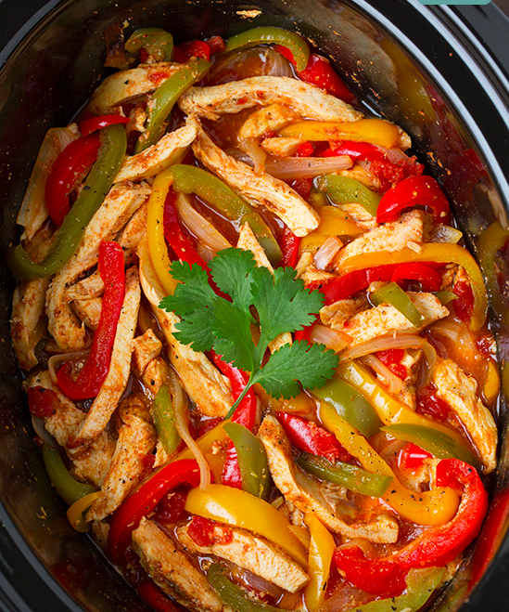
Ingredients
- 2 lbs boneless skinless chicken breast halves
- 1 (14.5 oz) can petite diced tomatoes with green chilies
- 1 red, orange and green bell pepper, julienned
- 1 large yellow onion, halved and sliced
- 4 cloves garlic, minced
- 2 1/2 tsp chili powder
- 2 tsp ground cumin
- 1 tsp paprika
- 3/4 tsp ground coriander
- 1 tsp salt
- 3/4 tsp pepper
- 2 Tbsp fresh lime juice
- 1 Tbsp honey
- For serving:
- Flour tortillas, sour cream, cilantro, salsa, guacamole, monterrey jack or cheddar cheese

Directions
- Pour half of the canned tomatoes into the bottom of a slow cooker and spread into an even layer. Top with half of the peppers and half of the onions. Sprinkle garlic in. Top with chicken breasts.
- In a bowl whisk together chili powder, cumin, paprika, coriander, salt and pepper. Evenly sprinkle half of the seasoning over chicken breasts then flip chicken and sprinkle in remainder. Top with remaining half of the tomatoes, then layer in remaining peppers and onions.
- Cover and cook on HIGH heat 3 - 4 hours or low heat 6 - 8 hours, until chicken has cooked through and veggies are tender (note that if you want to be able to cut chicken into strips cook more near lesser time on HIGH or LOW, otherwise it will probably just shred, which is also fine).
- Remove chicken, and cut into strips, or shred. Ladle out 1 cup of the broth in slow cooker (mostly tomato liquid) and discard. In a small bowl whisk together lime juice and honey and add to slow cooker along with chicken and season with additional salt to taste if desired. Gently toss. Sere warm in warmed tortillas with sour cream and optional guacamole, cheese and salsa.

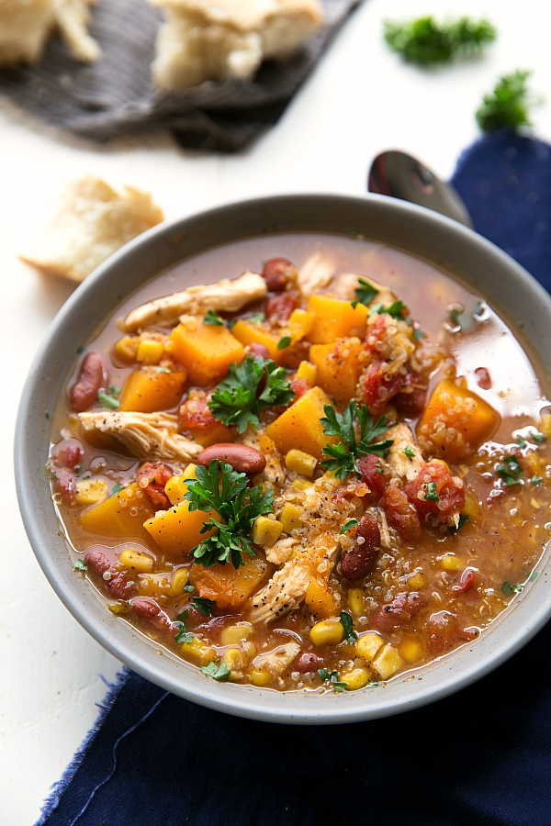
CROCKPOT BUTTERNUT SQUASH, CHICKEN, AND QUINOA SOUP
INGREDIENTS
- 1 and 1/2 pounds boneless skinless chicken
- 1 cup quinoa
- 1 small butternut squash (~4 cups)
- 1 can (15.25 ounces) kidney beans
- 1 can (15 ounces) corn
- 1 can (14.5 ounces) petite diced tomatoes*
- 2 teaspoons minced garlic
- 1 packet (1.12 ounces) fajita seasoning mix
- 5 cups chicken broth*
- Salt and pepper, to taste
- Optional: fresh parsley
INSTRUCTIONS
- Remove the fat from the chicken. Rinse the quinoa in a fine mesh sieve to remove the bitter saponin coating
- Peel, seed, and chop the butternut squash into small bite-sized pieces
- Rinse and drain the kidney beans and corn.
- Lightly grease your slow cooker with nonstick spray. Add in the chicken, quinoa, chopped squash, kidney beans, corn, undrained tomatoes, garlic, and fajita seasoning packet.
- Pour in the chicken broth and stir.
- Cover and cook on high for 3-4 hours or until the quinoa is cooked through and the squash is very tender.
- Optional! Remove some of the squash, mash, and then put it back in. This makes heartier.
- Add salt and pepper to taste. Garnish with fresh parsley if desired.
- NOTE: Slow cookers are known for cooking at different speeds!

CROCKPOT CHICKEN AND SHRIMP JAMBALAYA

Ingredients:
- 2 pounds boneless, skinless chicken breast, thawed, excess fat removed
- 1/2 cup diced fresh green bell pepper
- 2 cups finely diced fresh celery
- 1 cup finely chopped yellow onion
- 2 cups diced tomatoes, with juices (canned or fresh)
- 2 cups chicken broth
- 1 6-oz tomato paste
- 2 cloves garlic, minced
- 3 TBSP cajun seasoning (we used Tony Chachere's but you can also make your own seasoning)
- 1 tsp sea salt
- 1 lb uncooked shrimp, fresh, peeled and deveined
- 2 cups brown rice or quinoa
Directions:
- Combine chicken breasts, bell pepper, celery, onion, tomatoes, paste, broth, garlic, seasoning and salt into large, 6-quart crockpot or slow cooker.
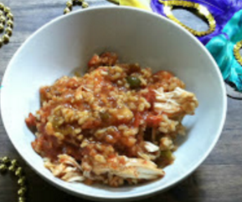
- Cover and cook on low heat for approximately 6 hours or high heat for approximately 3 hours. Stir intermittently if needed.
- Take Chicken out and cut or pull apart, put back in
- Add rice and shrimp to slow cooker, stirring to combine. Cook on low for 2 additional hours or high for 1 hour.

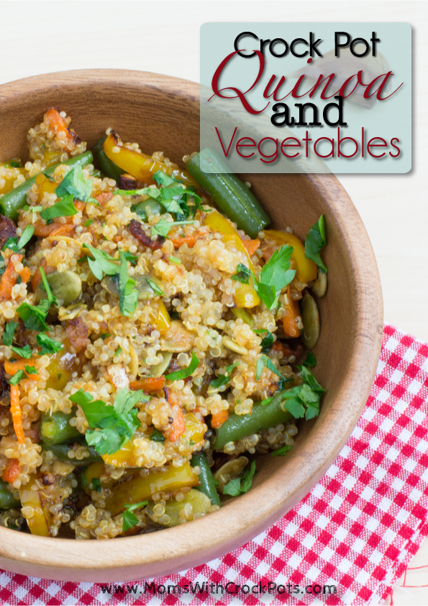
CROCK POT QUINOA WITH VEGETABLES
INGREDIENTS
- 1½ cups Quinoa
- 3 Cups Chicken or Vegetable Stock
- 1 small onion, chopped
- 1 tablespoon olive oil
- 1 medium sweet red pepper, chopped
- 1 small carrot, chopped
- 1 Cup Fresh Green Beans chopped
- 2 garlic cloves, minced
- 1 teaspoon fresh cilantro or basil (depending on your taste)
- ¼ teaspoon pepper
INSTRUCTIONS
- Rinse Quinoa
- Dump it into the crock pot. (I used 6 quart)
- Add 1 tablespoon of olive oil to coat.
- Stir in broth, veggies, pepper and garlic. Reserve cilantro for before serving.
- Cover and cook on low for 4-6 hours, or on high for 2-4.
- The quinoa is done when you can fluff it with a fork and it is tender. Liquid should be absorbed into quinoa.
- Top with fresh cilantro and serve.
- You can mix in garbanzo beans or black beans to add protein to this dish and turn it into a meal

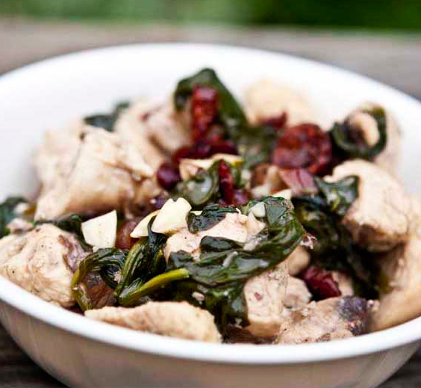
Coconut Almond Cranberry Chicken

Ingredients:
- 1/2 cup almonds, chopped
- 1 (15 ounce) can light coconut milk
- 1/2 cup dried cranberries (I used fruit juice sweetened cranberries from Whole Foods)
- 4 cups raw spinach leaves, tightly packed when measuring
- 4 chicken breasts (about 7 ounces each), chopped into bite-sized pieces
- 1/2 teaspoon finely grated fresh ginger (grate on a microplane for best results)
- 1/2 teaspoon cinnamon

Directions:
- Combine all ingredients in a large pan and cook over medium to medium-high until the chicken is fully cooked through. Serve by itself or over brown rice or whole grain pasta.

Simple Chicken Curry Recipe
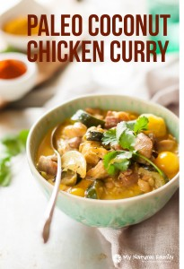

Ingredients
- 2 T. Olive Oil or Coconut Oil
- 8 Chicken Thighs(boneless, skinless), cut into 1" pieces
- 1 Large Onion, cut into large chunks
- 3 Small Zucchini, Cut in half lengthwise and thickly sliced
- 1 t. Garlic, minced
- 1 T. Curry Powder
- ½ t. Paprika
- 2 t. Coarse Real Salt
- 2 Cans (about 15 oz each) Coconut Milk
- 1 C. Yellow or Red Grape tomatoes
- Cilantro, to garnish
Instructions
- Heat the olive oil in a stock pot to high heat. Add the chicken and cook until chicken pieces are browned on both sides. Remove the chicken from the pan and set aside, keeping the remaining oil in the stock pot.
- Add the onion and zucchini and saute until lightly browned. Add the garlic, curry powder, paprika, and salt and saute for 30 seconds.
- Add the chicken back into the pot, along with the coconut milk. Bring to a boil.
- Reduce heat to a simmer, cover the pot with a lid, and let simmer for 30 minutes, or until chicken is tender. Add the tomatoes to the pot in the last 5 minutes of cooking.
- Serve in a bowl with the coconut broth, like a soup. Top with cilantro.

